What is in a product backlog?

In agile development, a product backlog (often referred to simply as a backlog) is a list of all things — new features, bug fixes, improvements, changes to existing features, and other product initiatives — that product teams must prioritize and deliver in order for a product to strategically come to life.

What is Agile:

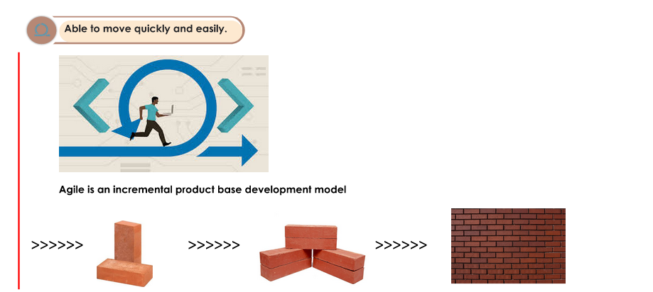

Agile Lifecyle:

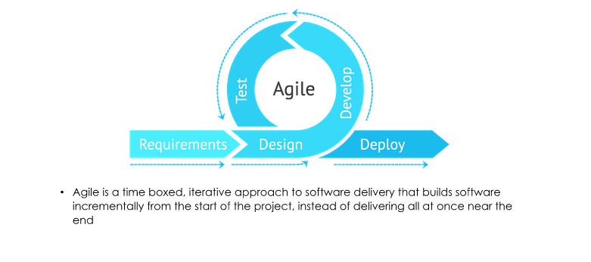

Agile History:

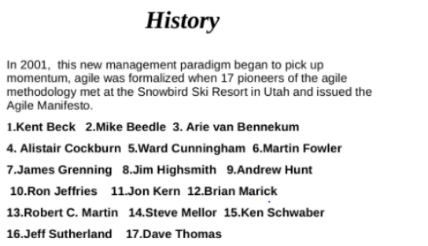

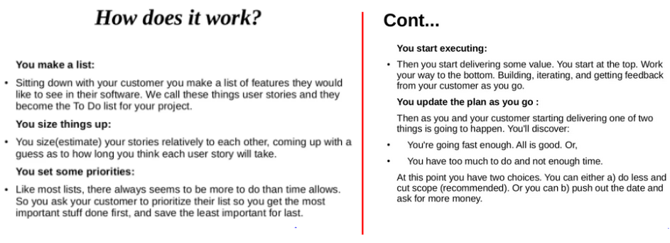

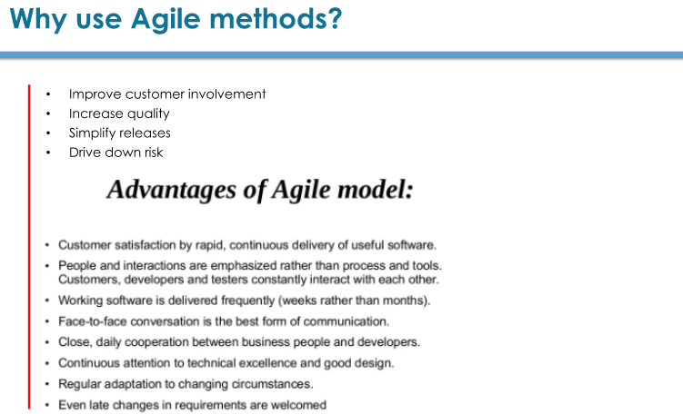

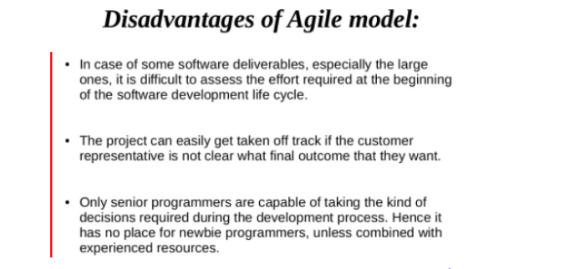

Terms: SDLC, Waterfall, Agile, Project, Sequential execution, Parallel execution, Product backlog, Developer, Tester, business Analyst, Project Manager, Program manager, Product owner, Stakeholders.